Full Stack Development with MERN
Project Documentation format
1. Introduction
• Project Title: Streamlining IT Procurement: Automating Standard Laptop Orders with Flow Designer (built on ServiceNow, Team 7)
• Team Members: Team 7. Roles follow the sprint plan in the project planning document.
o Haresh S: Team Leader. Creates the "Standard laptop task" flow, sets the Assignment group and Approval on the catalog task, adds the flow to the Standard Laptop item, tests approval, fixes issues found in testing and presents the final demo.
o Gobika M: Adds the Service Catalog trigger, saves and activates the flow, saves the catalog item, checks the order status and task confirmation, and prepares the project documentation.
o Hariharan M: Adds the Create Catalog Task action using the Requested Item record, finds the Standard Laptop item in Maintain Items, verifies the generated catalog task and checks Flow Designer execution details.
o Harini G: Sets the short description and description, removes the existing automations from the catalog item, tests Order Now, verifies the task details on the Hardware group and runs the end-to-end test.
2. Project Overview
• Purpose: To make IT procurement for standard laptops efficient and consistent. After a Standard Laptop request is approved, the configuration step used to depend on someone creating and assigning a task by hand, which was prone to oversight or delay. The project automates that step with ServiceNow Flow Designer so laptops are configured promptly on arrival, with less manual effort and shorter waits for users.
• Features:
o Employees order a Standard Laptop through Service Catalog > Hardware > Order Now and follow the request through its Request Number.
o The approver approves the request from the Approvers section of the request record.
o The flow "Standard laptop task" (Application: Global, Run user: System user, Service Catalog trigger) runs automatically.
o The Create Catalog Task action creates a catalog task from the Requested Item record with the short description and description "Laptop need to Configured", Assignment group Hardware and Approval Approved.
o The flow is attached to the Standard Laptop catalog item through Maintain Items > Process engine, so every order follows the same path.
o The Hardware team and requester can follow the task in the Catalog tasks section of the Requested Item.
3. Architecture
This project is a low-code ServiceNow solution. React, Node.js, Express.js and MongoDB are not used; the equivalent layer of each is described below.
• Frontend: React is not used. The user interface is the ServiceNow web interface (Service Catalog / Service Portal, with platform-provided HTML, CSS and JavaScript). Employees order from Service Catalog > Hardware > Standard Laptop > Order Now, approvers work in the Approvers section of the request record, and the Hardware team works in the catalog task records.
• Backend: Node.js and Express.js are not used. The backend logic is the Flow Designer flow "Standard laptop task" (Application: Global, Run user: System user, Trigger: Service Catalog) with the Create Catalog Task action. The flow is attached to the Standard Laptop catalog item through Maintain Items > Process engine and runs on the ServiceNow cloud instance. No external API and no machine learning model are used.
• Database: MongoDB is not used. Data is stored in the ServiceNow platform database, hosted on the cloud instance, in these tables:
Table | Holds | Key fields used
sc_request | The request and its Request Number | Request Number, approval
sc_req_item | The Requested Item (the Standard Laptop order) | Requested Item record used by the flow
sc_task | The Catalog Task created by the flow | Short description, description, assignment group, approval

The flow reads the Requested Item record and writes one catalog task per request. No custom schema or models were defined.
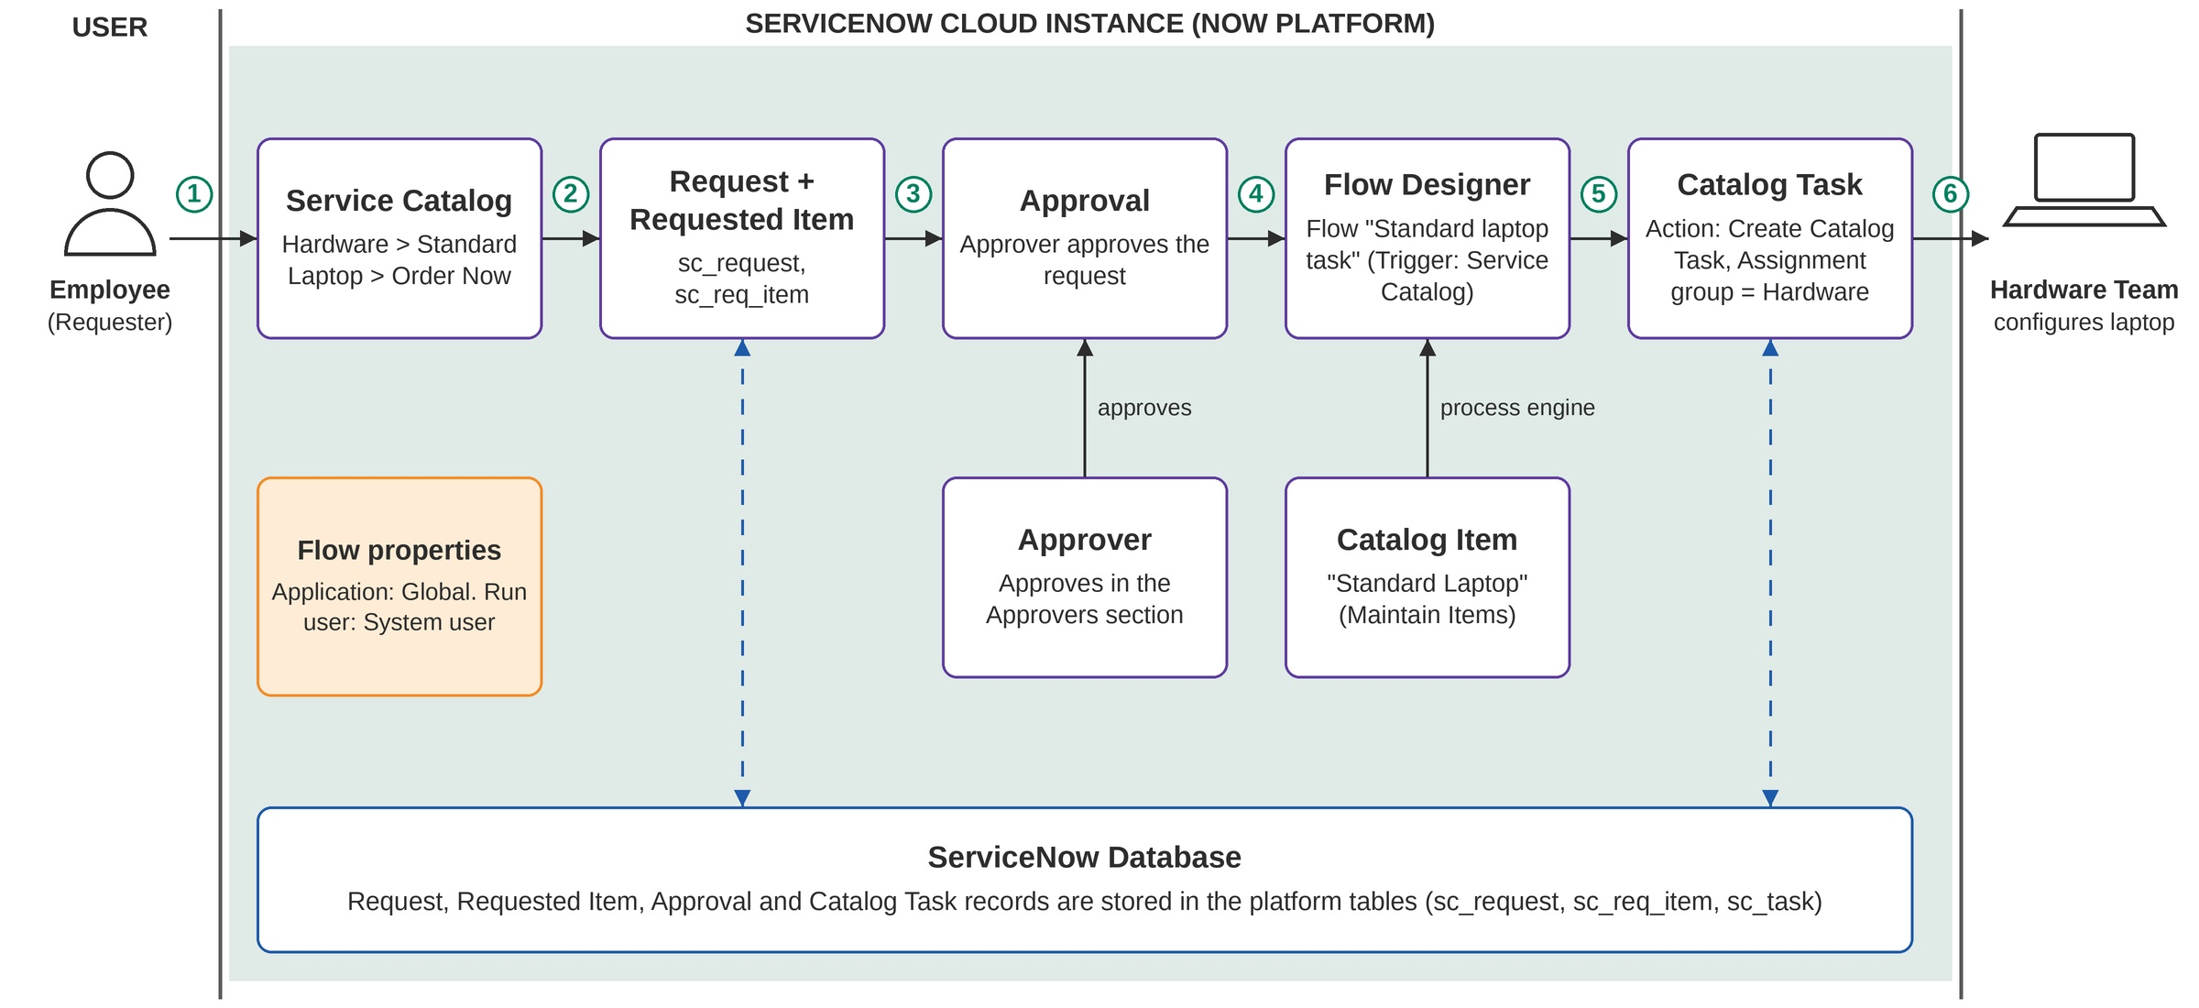
Figure 1: Architecture and data flow of the automated standard laptop order process
4. Setup Instructions
• Prerequisites: Node.js and MongoDB are not required and nothing is installed locally. You need:
o A web browser.
o A free ServiceNow Personal Developer Instance (PDI) from the ServiceNow Developer Program.
o An administrator account on the instance, to use Flow Designer and Maintain Items.
o Users to test with: a requester, an approver and a member of the Hardware group.
• Installation: There is nothing to clone or install with npm and no .env file. The application is configured directly on the instance:
o 1. Request a PDI from the ServiceNow Developer Program and log in to it as an administrator.
o 2. Open All > Process Automation > Flow Designer and create a flow named "Standard laptop task" (Application: Global, Run user: System user).
o 3. Add the Service Catalog trigger.
o 4. Add the Create Catalog Task action and drag the Requested Item record into it.
o 5. Set the short description and description to "Laptop need to Configured", the Assignment group to Hardware and Approval to Approved.
o 6. Save and activate the flow.
o 7. Open All > Maintain Items, open the Standard Laptop item, go to the Process engine tab and remove the existing automations.
o 8. Add the "Standard Laptop Task" flow to the item and save the record.
Environment variables: none are needed. All configuration is stored on the instance.
5. Folder Structure
• Client: There is no React client folder. The user-facing parts are configuration records on the ServiceNow instance, not source files: the Hardware category in the Service Catalog, the Standard Laptop catalog item, and the platform forms for the request, Requested Item and catalog task.
• Server: There is no Node.js server folder. The server-side logic is one Flow Designer flow stored on the instance, with data in the platform tables. The logical organisation is:
ServiceNow instance
|-- Service Catalog > Hardware > Standard Laptop (catalog item)
|-- Flow Designer > Flows > Standard laptop task
| |-- Trigger: Service Catalog
| `-- Action : Create Catalog Task
`-- Platform tables: sc_request, sc_req_item, sc_task

6. Running the Application
• No local servers are started and no npm commands are used. The application runs on the ServiceNow cloud instance once the flow is active.
o Frontend: There is no npm start. Open the instance URL in a browser, log in, and go to Service Catalog > Hardware > Standard Laptop > Order Now.
o Backend: There is no npm start. The flow runs automatically on the instance after the request is approved. To check a run, open the Flow Designer execution details.
7. API Documentation
• The project exposes no custom REST endpoints and calls no external API. The ServiceNow platform Table API is not used. The equivalent interfaces are the user actions and the flow, described below.
• Request methods, parameters and example outputs are given as the inputs and outputs of each step:
Interface | Input / parameters | Output / example result
Order Now (Service Catalog) | Standard Laptop item opened from Service Catalog > Hardware | A request is created and its Request Number is shown in the order status
Approve (Approvers section) | Approval record, approved by right-click > Approve | Approval state changes to Approved
Flow "Standard laptop task" | Trigger: Service Catalog; input: the Requested Item record | Flow runs as System user and creates the catalog task
Action: Create Catalog Task | Short description and description = "Laptop need to Configured"; Assignment group = Hardware; Approval = Approved | A catalog task appears under Catalog tasks of the Requested Item, assigned to Hardware

8. Authentication
• Authentication and authorization are handled by the ServiceNow platform: users log in with their instance accounts, access is controlled through roles and ACLs, and the instance is accessed over HTTPS (TLS).
• The project does not implement its own tokens or sessions; the login session is managed by the platform. The flow runs as the System user. The roles involved are:
User | What they can do in this project
Requester (Employee) | Orders the Standard Laptop and opens the Request Number to track the order
Approver (Manager) | Sees the pending approval in the Approvers section and approves it
IT Procurement Team (Flow Administrator) | Creates, activates and attaches the flow
Hardware Team Member | Receives the catalog task in the Hardware assignment group and views its status

9. User Interface
• Screenshots to be added. The screens to capture are:
o Service Catalog > Hardware, showing the Standard Laptop item.
o The Standard Laptop item with the Order Now button, and the order status with the Request Number.
o The Approvers section of the request record.
o The flow "Standard laptop task" in Flow Designer, showing the trigger and the Create Catalog Task action.
o Maintain Items > Standard Laptop > Process engine, showing the assigned flow.
o The catalog task under Catalog tasks, showing short description, assignment group and status.
10. Testing
• The testing strategy is manual User Acceptance Testing (UAT) on the ServiceNow instance. Automated test frameworks such as Jest or Mocha are not used. The test cases cover both positive and negative scenarios, and an end-to-end test with a check of the Flow Designer execution details is planned for Sprint-4. Results are left blank until the tests are run.
Test Case ID | Test Scenario | Result
TC-001 | Standard Laptop item is available in the catalog
TC-002 | Place a standard laptop order
TC-003 | Approve the request
TC-004 | Catalog task is created after approval
TC-005 | Task fields are set by the flow
TC-006 | Flow is assigned to the Standard Laptop item
TC-007 | Negative: no catalog task before approval
TC-008 | Negative: rejected request creates no task

11. Screenshots or Demo
• Screenshots: to be added.
• Demo link: to be added. A final demo of the automated laptop order flow is planned for Sprint-4.
12. Known Issues
• Limitations of the current design:
o Only standard laptops are covered; other hardware items need their own flow.
o Approval still depends on a person, so the request waits until the approver responds.
o The task text is one fixed phrase ("Laptop need to Configured") with no requester or laptop details.
o The employee is not notified automatically; status is checked by opening the request records.
o The solution depends on the ServiceNow platform and on the Hardware team's availability to configure the laptop.
• To verify in testing: the flow uses a Service Catalog trigger, so TC-007 and TC-008 should confirm that the catalog task is created only after approval.
• No bugs are recorded yet, because the test cases have not been executed.
13. Future Enhancements
• Potential future features and improvements:
o Email the user when the laptop is ready.
o Escalate a catalog task automatically if it sits idle.
o Send a Slack alert to the Hardware team when a task is created.
o Add a dashboard for turnaround time from approval to configuration.
o Auto-approve low-cost standard laptops.
o Auto-reorder laptops when stock is low.
o Reuse the same flow pattern for other standard hardware items.

